PROGRAMMING TECHNIQUES

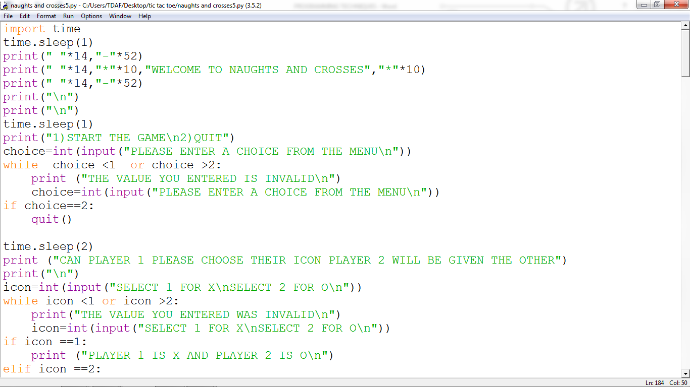

A Variable is a stored bit of information that has a name, data type and value. I have set variables that have values that change throughout the code. These variables are referred to as global variables which are set outside a procedure as opposed to local variables which can only be used within procedures global variables. One advantage of using global variables is that the values can be called by any procedure or function in the program.

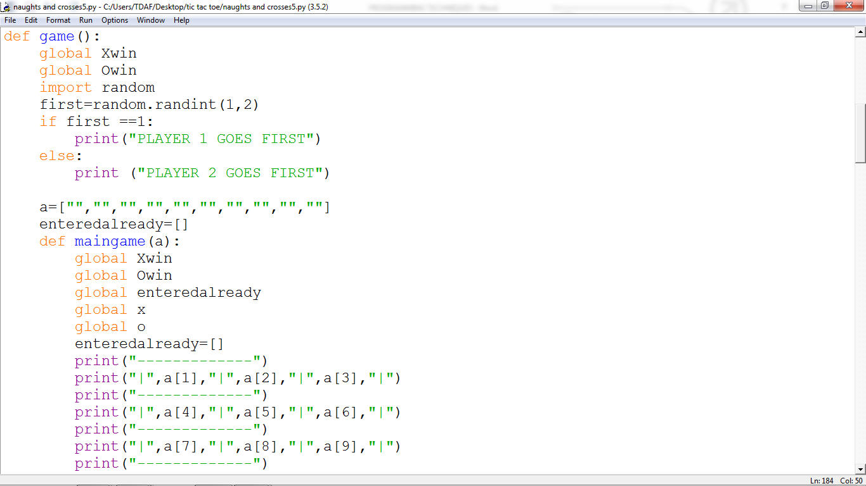

Procedures are sections of code in a program that perform a specific task. They can be used repeatedly throughout a program. Procedures have also been used in my code. Within these procedures, I have set a few local variables.

The print function has been used in the program as well; this is in order to display text and other outputs that the user will see. This is the most repeated piece of code throughout the program as it is key because, it allows communication with the user. I have used the print function to ask the user questions in order to receive inputs and make titles which make the program easy to navigate

The import command has been used in order to retrieve modules from the python library. This is useful because, it means that I do not need to write out long pieces of code as they have been provided for me.

The time module allows me to add delays within my code. This makes the outputs more readable thus making the program easier to follow for the user. I am able to access the time module by typing “import time” this allows my code to access the library where the module is saved, after this I would type “time. Sleep()”. Within the brackets I would put in the number of seconds that I want the program to delay for.

The random module allows me to get the program to randomly generate a number from a range of values that have been set. E.g., random.randint is used by the program to place the Treasure chest and Bandit values, randomly, around the grid.

The while loop is a form of conditional loop. This means, that it will cause the program to infinitely loop until a certain pre-defined condition has been met by the user. In the code, the while loop is used as a form of validation where it stops the users progress if, the values they enter are invalid. In the screenshot above, I have made sure that the user cannot advance unless they have chosen either option 1 (START THE GAME) or option 2 (QUIT).

The input function allows the user to interact directly with the program. It is used throughout the program to obtain information for the game. The input function works alongside the print function with the purpose of creating values for variables that are set by the user. This is done by using the print function to ask the user to input data. The input function to saves this data under a variable name.

The quit function has been used in order to give the user the option to end the program/ exit the game. It acts as an escape from the program.

The INT function is used in conjunction with a variable, the input function and the print function. It is an example of a data type. The INT function allows the user to enter integers/ whole numbers. A variable will take on this input value